Visiting Family for an early Christmas

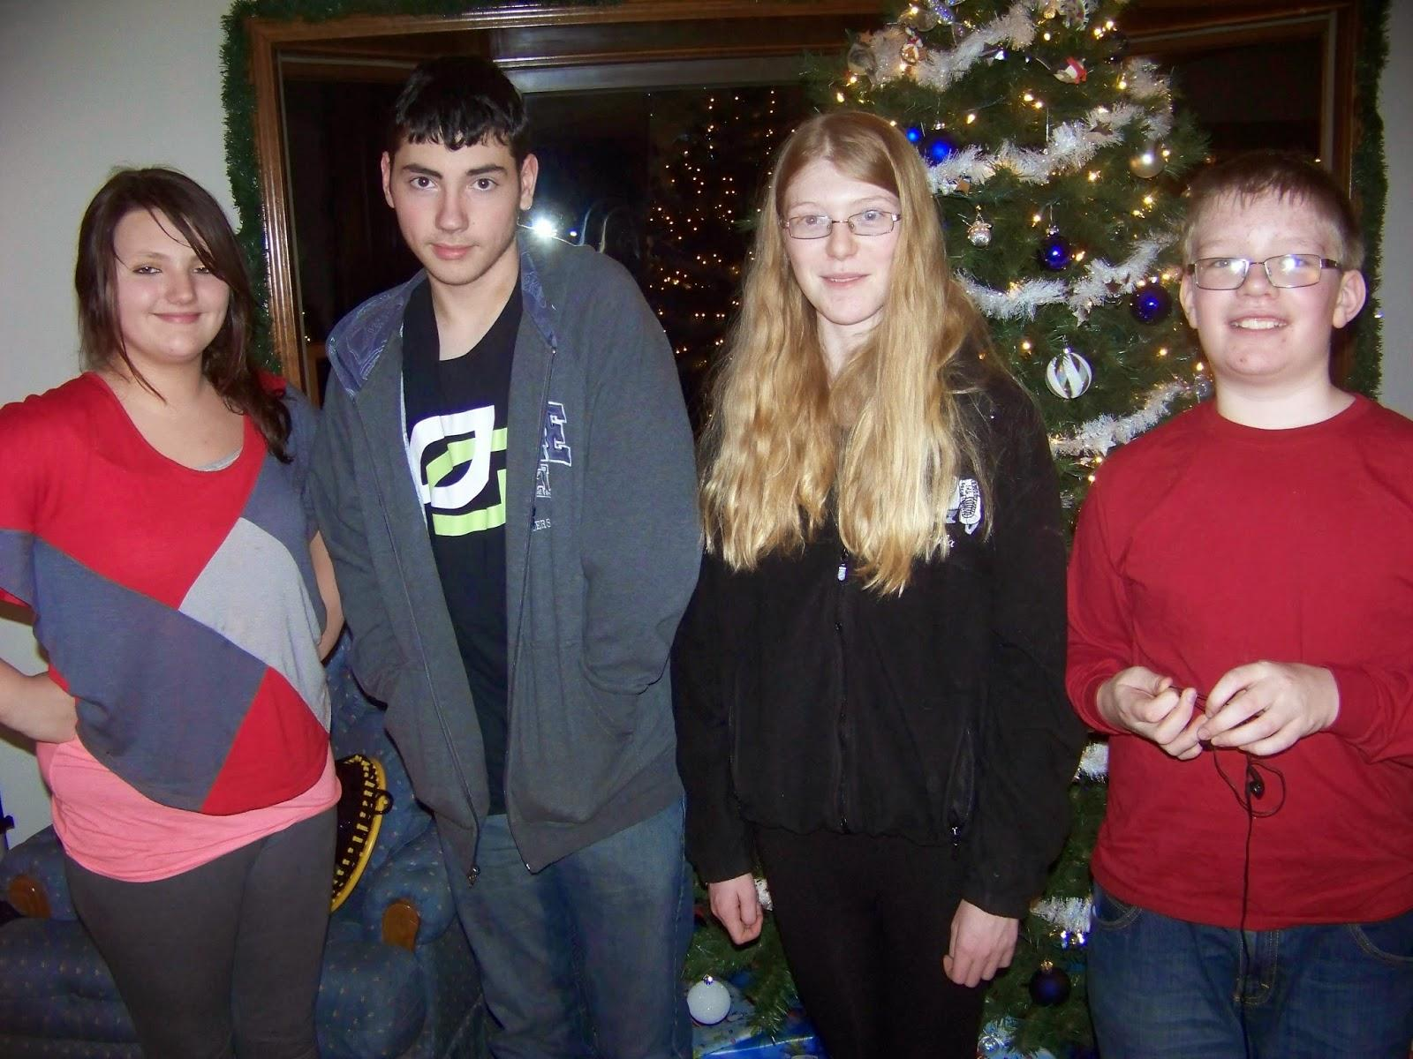

A visit with family is made up of so many different good moments, that our trip to see my in-laws’ house probably deserves its own series of articles. Last weekend we made the trip to Marlette, MI where we celebrated an early Christmas with my wife’s family.

This was a rare opportunity to see my brother-in-law Jeff and his wife Kim who were both visiting from out of state. And, the kids were able to see their cousins.

Once we got into the groove of things, the evening felt as if Christmas had actually come early. After dinner, we gathered around the Christmas tree and waited while the kids distributed the gifts.

I don’t know if I would call them “traditions,” but there is something about the routines we fall into when we celebrate Christmas with my in-laws that feels very comfortable. There has always been a question of logistics when it comes to finding a seat for everyone. For a few years, there was at least one kid in a high chair, and for a few years there were two. Then, the “kid’s table” would be a small blue card table. Some years, they sat in the kitchen. This year, my mother-in-law set up a card table for the four preteens to sit next to. Allyson, the oldest of the nieces and nephews, has been sitting with us at the dining table for a few years now.

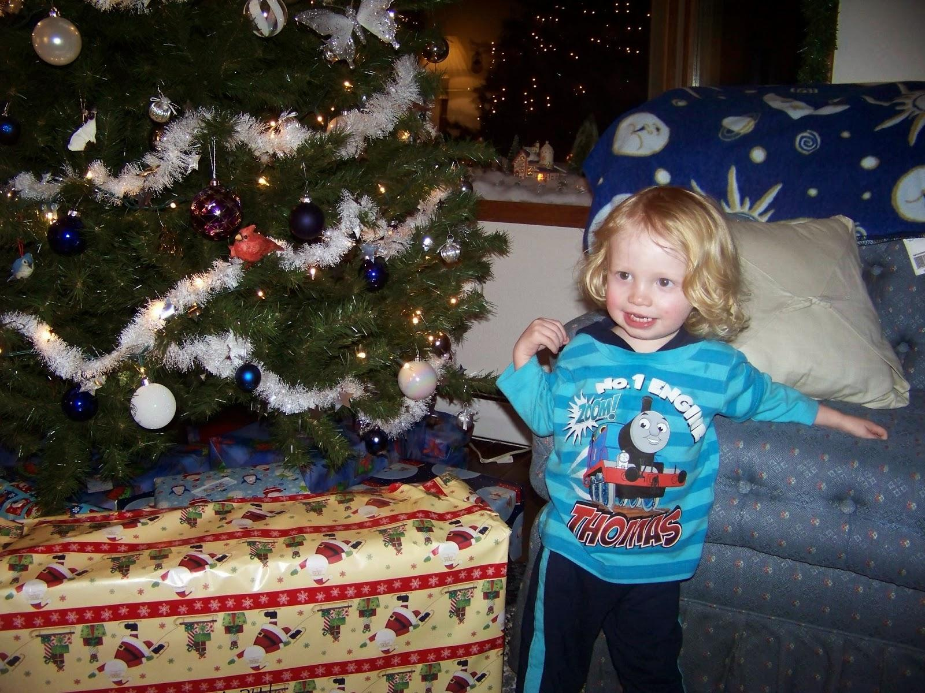

Elijah sat in his highchair, of course, near the dining table.

The process for exchanging gifts has evolved as we’ve added more kids, and as those kids have grown older. This year, I think all of the nieces and nephews helped distribute the gifts to everyone. With the exception of Allyson, I can remember when each of them were too small to open up their presents on their own. This is the first year that Elijah was physically able to rip into his presents, but he didn’t understand well enough to be interested. But, that changed once we gave him a helpful nudge.

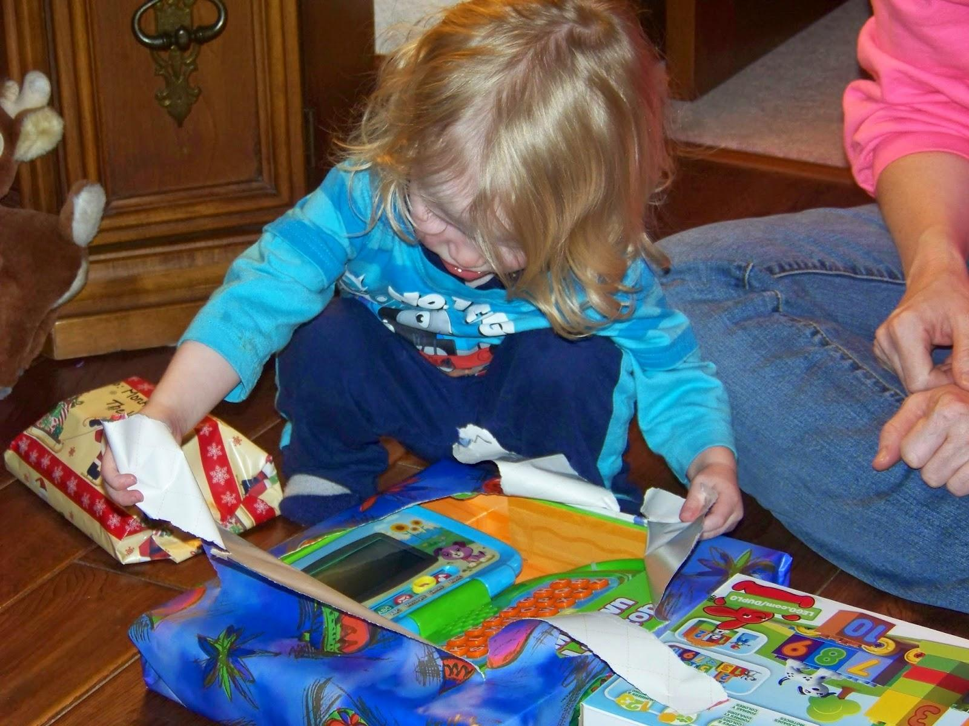

Things took a strange turn when my father-in-law began to open up his present from Jeff and Kim. What looked like an ordinary, wrapped present turned out to be six layers of boxes, all individually wrapped, with the last box containing a gift card.

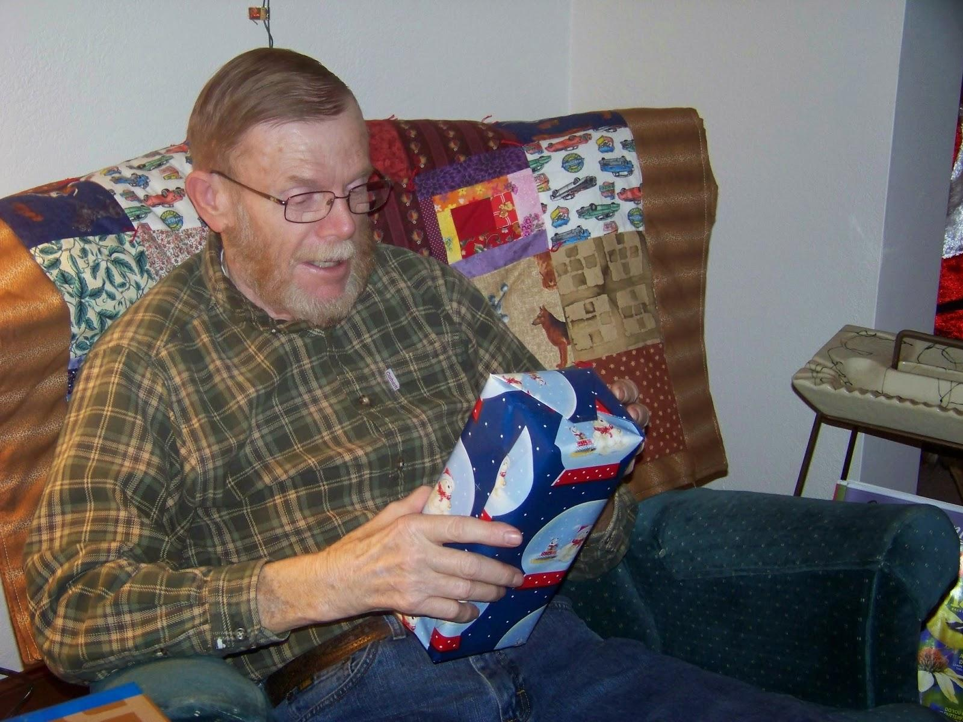

# Photo Gallery

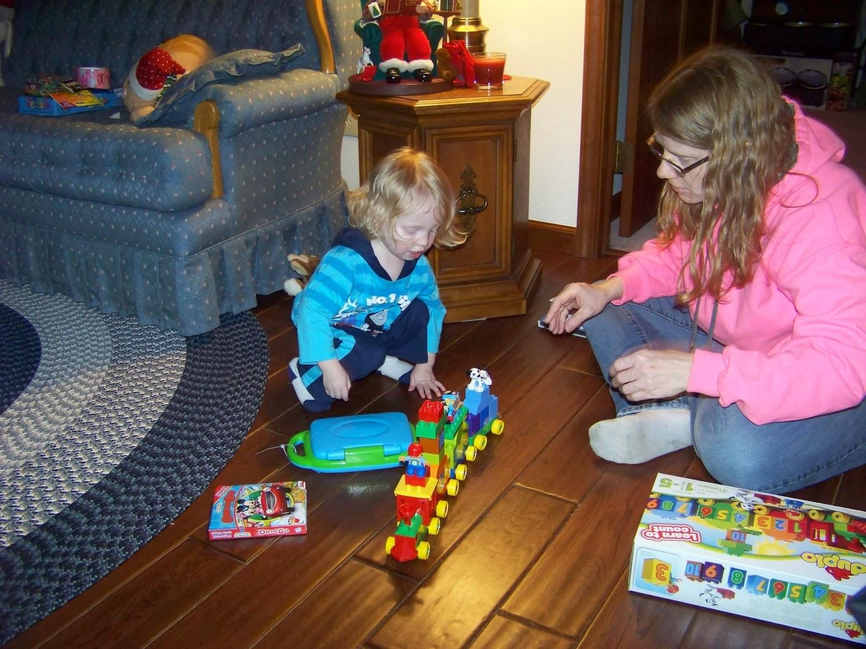

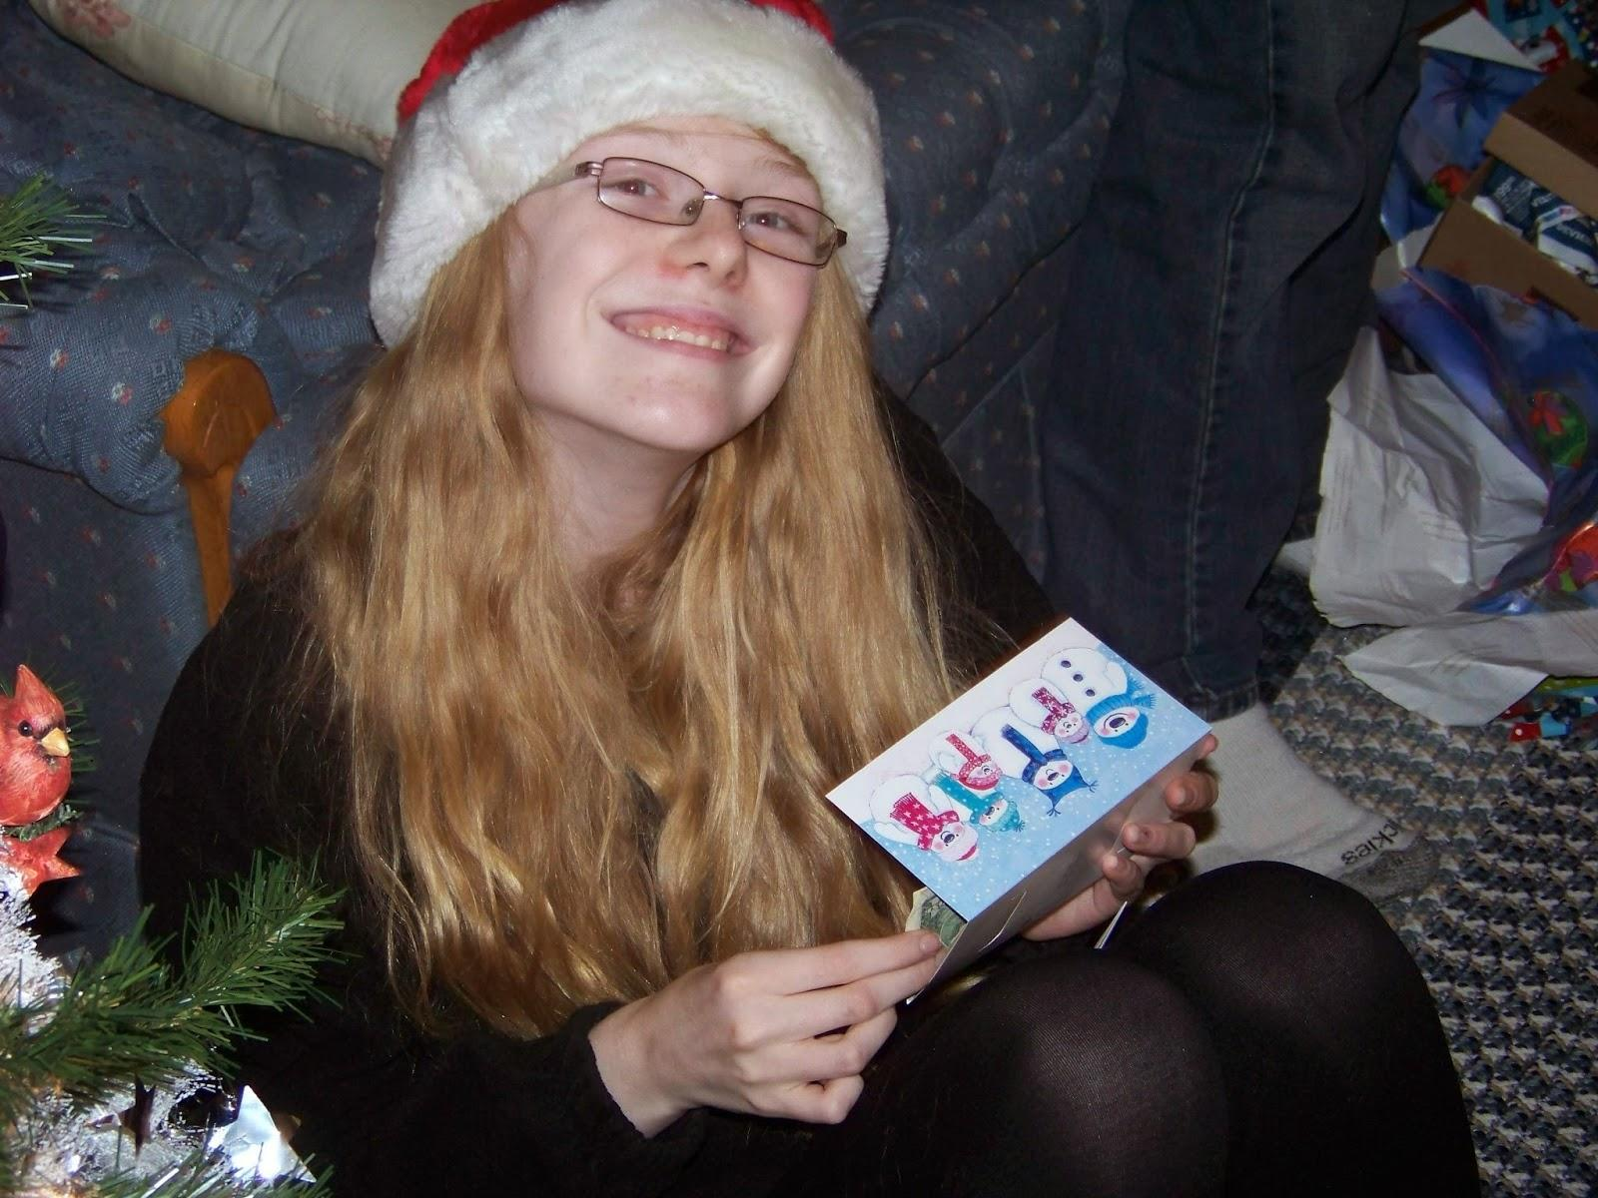

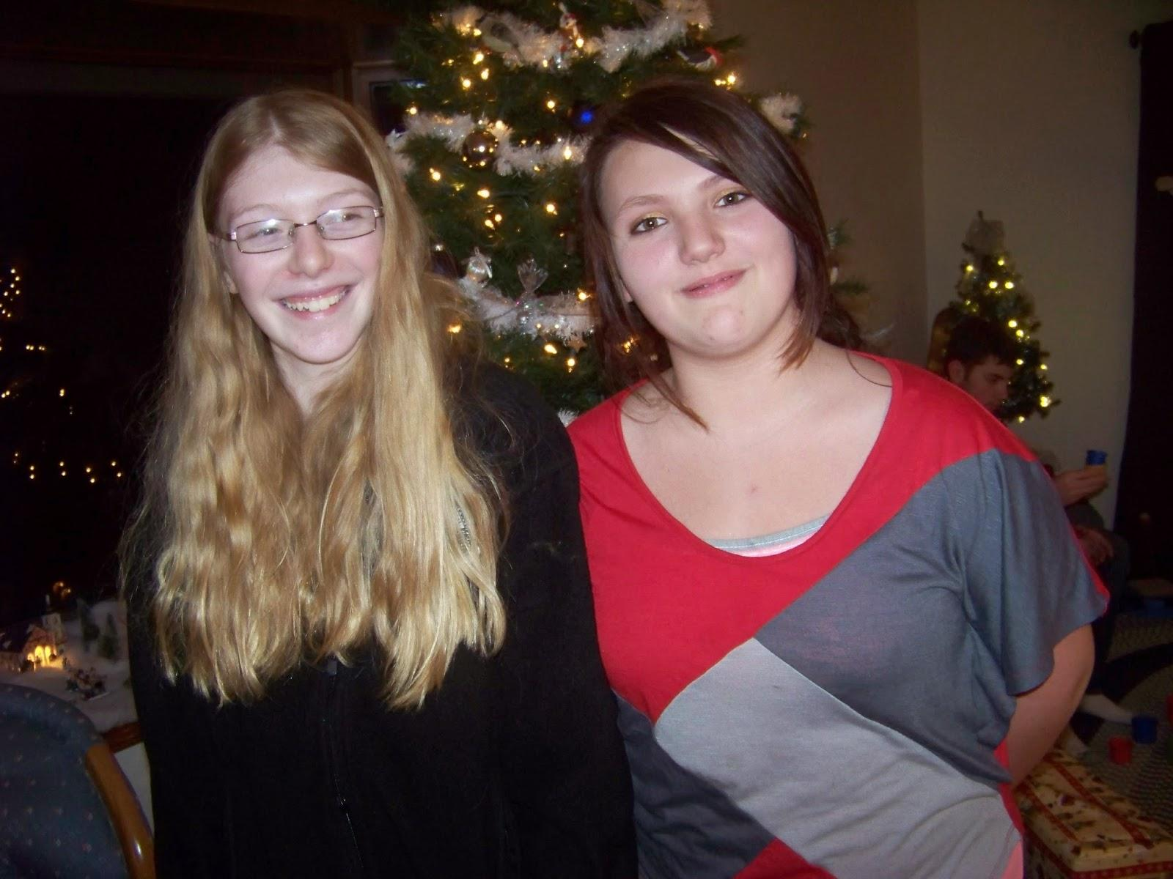

[View Online](https://medium.com/@morga2ja/visiting-family-for-an-early-christmas-7c76a8dc9aac) / [Post a comment](https://docs.google.com/document/d/10BWrWJJ0xkqEwOq8BBxzHHPhxnhTYsCjS20jWNoQTUw/edit?usp=sharing) / [Suggest Edits](https://quip.com/cV8iAbduQMcD) / [Respond to this story](https://medium.com/p/7c76a8dc9aac/responses/new) / [Send Email](mailto:cyberlandhq@gmail.com)